**VIVALDI ANTENNA DESIGN HFSS**

**PROCEDURE:-**

* OPEN ANSYS ELECTRONICS
* THEN OPEN HFSS
* GO TO DRAW🡪THEN SELECT EQUATION BASED SURFACE

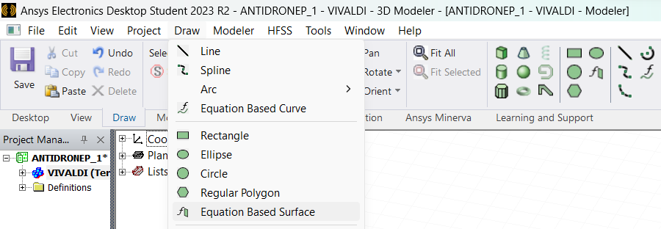

* THEN ENTER VALUES IN

* AFTER ENTERING THE VALUE PRESS OK

* THEN ENTER THE VARIABLE VALUES OF S,RATE ,TL

* AFTER SETTING THE PARAMETERS WE GET,

* **NOTE:-**

|  |  |
| --- | --- |
| s | HALF THE SLOT WIDTH |
| TL | TAPERING LENGTH OF THE CURVE |

Figure :HALF SLOT WIDTH(marked in red color)

Figure :THE MARKED ARROW IS THE TAPERED LENGTH